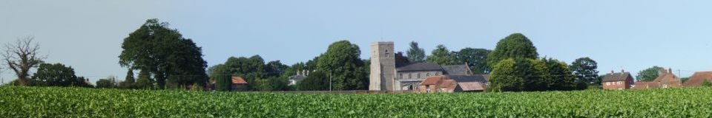
Marsham Parish Council

email: marsham_pc@outlook.com

NOTICE OF MEETING & SUMMONS TO ATTEND

THERE WILL BE A MEETING OF MARSHAM PARISH COUNCIL

TO BE HELD IN MARSHAM VILLAGE HALL,

ON MONDAY 8TH OCTOBER 2018 AT 7:30PM

In the interests of openness and transparency, councillors and members of the public are reminded that the law permits any person to film, record, photograph or use social media in order to report on the proceedings of a meeting of the Council. The Council request that anyone wishing to record the meeting lets the Council know beforehand so appropriate arrangements can be made to facilitate the recording.

A G E N D A

1. APOLOGIES FOR ABSENCE
To receive and accept Apologies for Absence as previously notified to the Parish Clerk

2. DECLARATIONS OF INTEREST & REQUESTS FOR DISPENSATIONS
To receive Members' Declarations of Interest in Agenda Items and to note the granting of any Requests for Dispensations

3. MINUTES
To receive, confirm and sign Minutes of the Parish Council Meeting held on
10th September 2018*

4. INFORMATION ON MATTERS ARISING
To receive information on any Matter Arising from the Minutes not listed elsewhere on the Agenda

5. REPORTS FROM POLICE
To receive written and/or verbal Reports from Representatives

6. REPORTS COUNTY AND DISTRICT COUNCILLORS
To receive written and/or verbal Reports from Representatives

7. TO ADJOURN THE MEETING TO ALLOW MEMBERS OF THE PUBLIC TO SPEAK

8. TO CONSIDER PLANNING ISSUES
a) APPLICATIONS FOR CONSIDERATION
No Applications Received
b) PLANNING UPDATES
To discuss planning updates including update on Hill House Marsham

9. FINANCE
a) To note balance of accounts
b) To approve payments to be made.

10. POLICIES
a) To adopt Complaints procedure*
b) To adopt bench policy*
c) To adopt Code of Conduct*

11. PARISH CLERK'S REPORT
a) To receive correspondence and agree action or responses*
b) To receive Clerks report*

12. TO ANSWER QUESTIONS FROM COUNCILLORS
Written questions should be given to the Clerk at least 3 days prior to the meeting.

13. COMPOST SITE – WOODFARM & ENVIRONMENT AGENCY
a) Monthly odour report from the environment agency for Marsham Area

14. MARSHAM VILLAGE HALL
To receive report from council representative

15. AMENITIES MATTERS (Peewit Fields / Allotments / Playground)
a) To receive updates on Peewit Field/Allotments
b) To receive update on the play area at George Edwards Close.
c) To look at the costing for surfacing under the climbing frame.

16. PUBLIC RIGHTS OF WAY
To consider any matters regarding the public rights of way.

17. MARSHAM SPEEDWATCH AND SAM 2 UNIT
a) To receive an update on Marsham Speed Watch
b) To receive an update on Marsham SAM 2 Unit

18. ANY OTHER BUSINESS
To note any other business raised

19. TO NOTE ITEMS FOR INFORMATION/FUTURE AGENDA
To note any items of Information or for referral to a future Agenda

20. DATE OF NEXT MEETING
To confirm the date of the next Meeting as Monday 12th November 2018 at 7:30pm at Marsham Village Hall

Mrs. N Carver 28th September 2018
Marsham Parish Clerk

*attached

NOTES
All documents referred to in this agenda as "attached" are supplied to Parish Councillors only. Copies are available (unless marked confidential) from the Parish Clerk.
Planning Applications listed above are those received at the time of publication of the Agenda. The Council may consider others received up to the date of the meeting if appropriate. Plans may be viewed at the meeting venue from 7:00p.m. on the date of the meeting. Alternatively, to view on line please go to www.broadland.gov.uk and follow the links through to planning.

